Contact Name
Business Address
Post Code
Home Phone |  |  | Mobile
Email
Facebook
Instagram
Twitter
WhatsApp
A full description of the products you will be selling at the festival
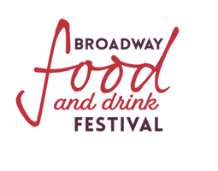
Do you supply any businesses in the village? | Yes/No
If Yes which businesses do you supply?

Is your insurance renewal date before September 13th 2026? If Yes please state here. | Yes/No
Name the local authority you are registered with.

Will you be cooking on the stall? | Yes/No
Will you be selling temperature-controlled food on the stall? | Yes/No

Do you perceive any Health and Safety risks?

Do you have any specific access requirements on the day?

Number of 3m indoor spaces required?
Number of 3m outdoor pitches required?

.$%$( &"  " "
$/+) $
.$%$( &"  " "
$/+) $
.$%$( &"  " "
$/+) $
N.B. If you are bringing a trailer or horsebox the charge will be for the full length of the trailer or horsebox, including the tow bar or back ramp when down. The charge will be £100 for 3 m of space with £30 more per additional metre or part metre. Please send pictures of your vehicle clearly showing where you will be serving from.

Amount of electricity supply required? (Please circle)
16A | X 1 | X 2 | X 3
32A | X 1 | X 2 | X 3

Please detail fully the equipment you will be using at the festival.

Agreement
The information in this application is accurate and true to the best of my knowledge. I have read and understood the Broadway Food Festival 2026 Terms and Conditions and agree to be bound by them. Our Terms and Conditions are located on our website.

Yes/No

Your name Date

Please email this along with your

- Current public liability insurance certificate,
- Completed Risk Assessment,
- Hygiene Certificate and rating evidence,
- Trailer or truck photographs,
- Photographs of your stall/products suitable for inclusion on our website and for use on social media (If we do not already have some) in high-res.

To

broadwayfoodfestival@gmail.com

